**CSS Chapter 2- Students Handout**

**Introduction**

Cascading Style Sheets (CSS) empower web designers to enhance the appearance of web pages using lists, hyperlinks, tables, borders etc..

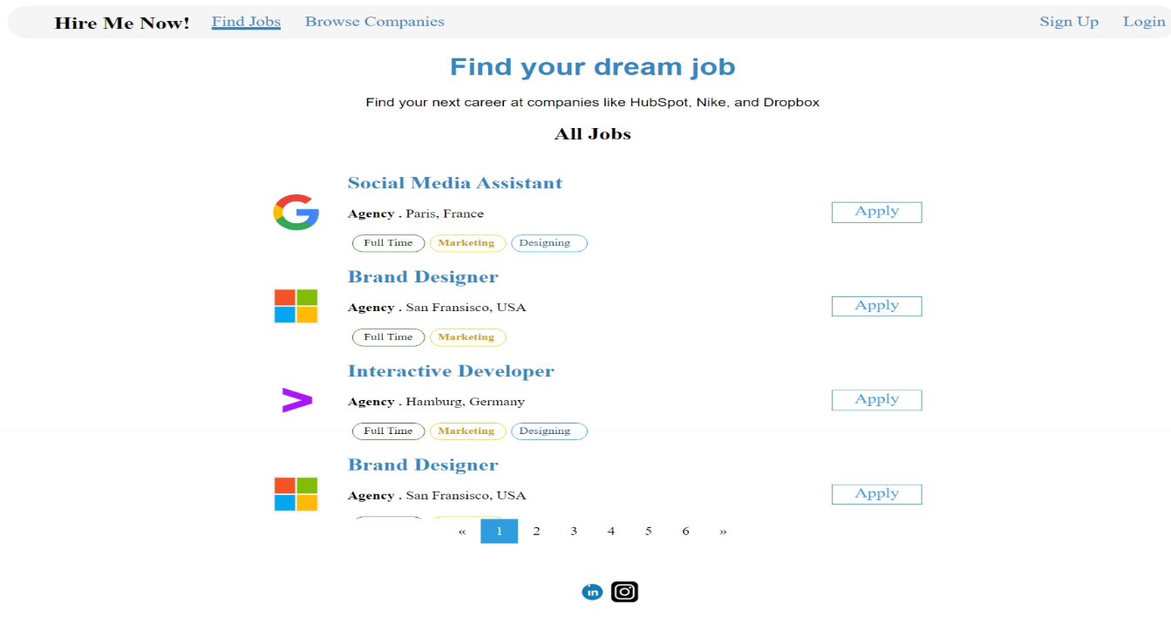**Workshop1**

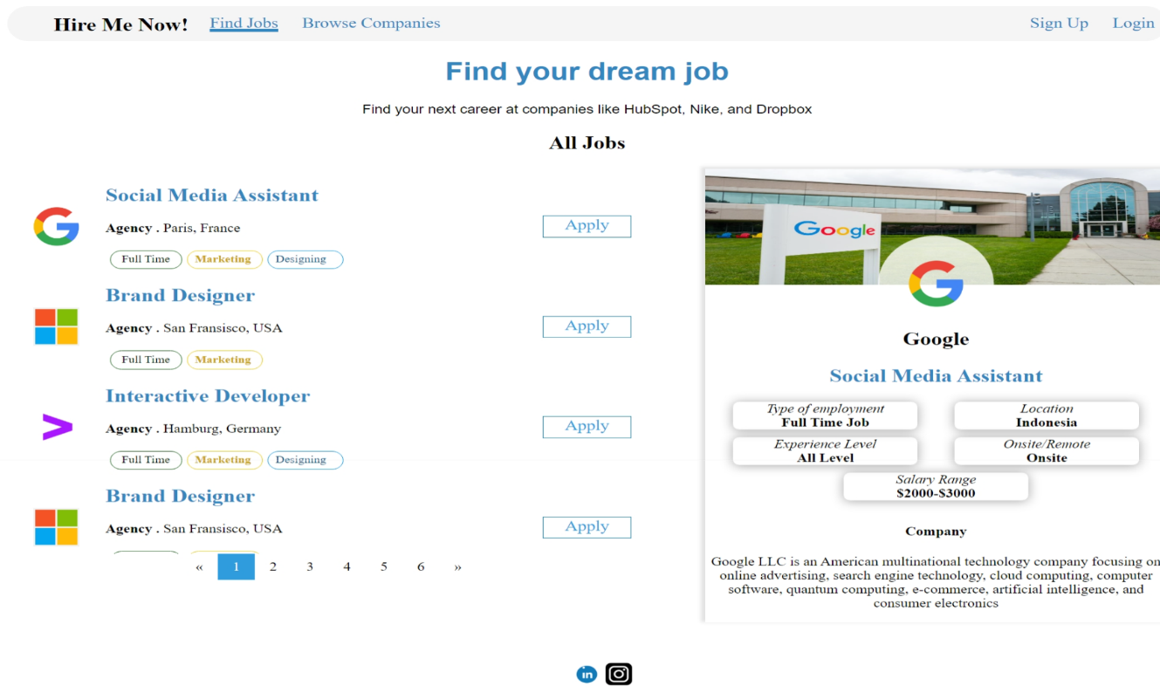**Expected Output:**

In workshop, you will learn how to use CSS styling properties to make your webpage visually appealing.

* The HTML structure begins with the `<html>` tag, enclosing the entire document.
* In the `<head>` section, we provide metadata like the page title and author's name, as well as a favicon for the browser tab.
* External styling is applied using an external CSS file named "ws1-style.css," linked in the `<head>` section.
* Inside the `<body>` tag, we start building the webpage.
* A navigation bar (`<div class="navbar">`) is placed at the top, containing links for finding jobs, browsing companies, logging in, and signing up.
* The main content is within a `<div>` element, featuring a centered `<h1>` heading for "Find your dream job" and a paragraph explaining the website's purpose.
* Below the main heading, we have another centered `<h2>` heading for "All Jobs."
* Within a container `<div>`, we list job postings. Each listing includes an image, job title, company details, and apply buttons.
* Job details are structured in an HTML table (`<table>`) for organized formatting. Each job is represented by a set of table rows (`<tr>`).
* These job listings show information like the company logo (`<img>`), job title, company location, job type, and categories (e.g., marketing and design).
* Pagination links are provided at the bottom to navigate through multiple pages of job listings.
* Finally, social media icons (Twitter, LinkedIn, and Instagram) are displayed at the bottom of the page.

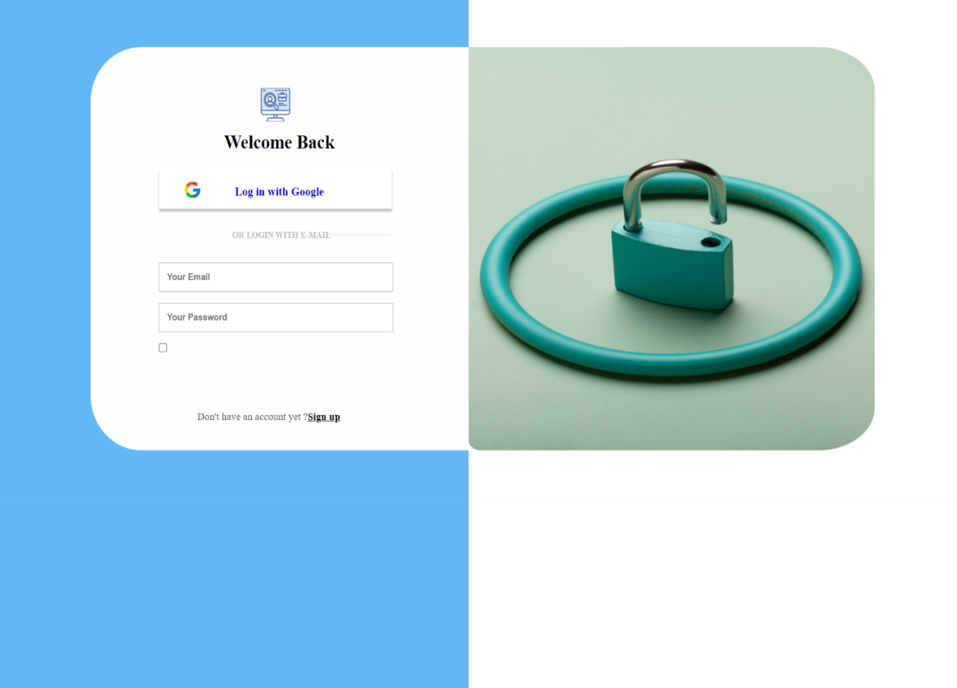**Workshop2**

**Expected Output**

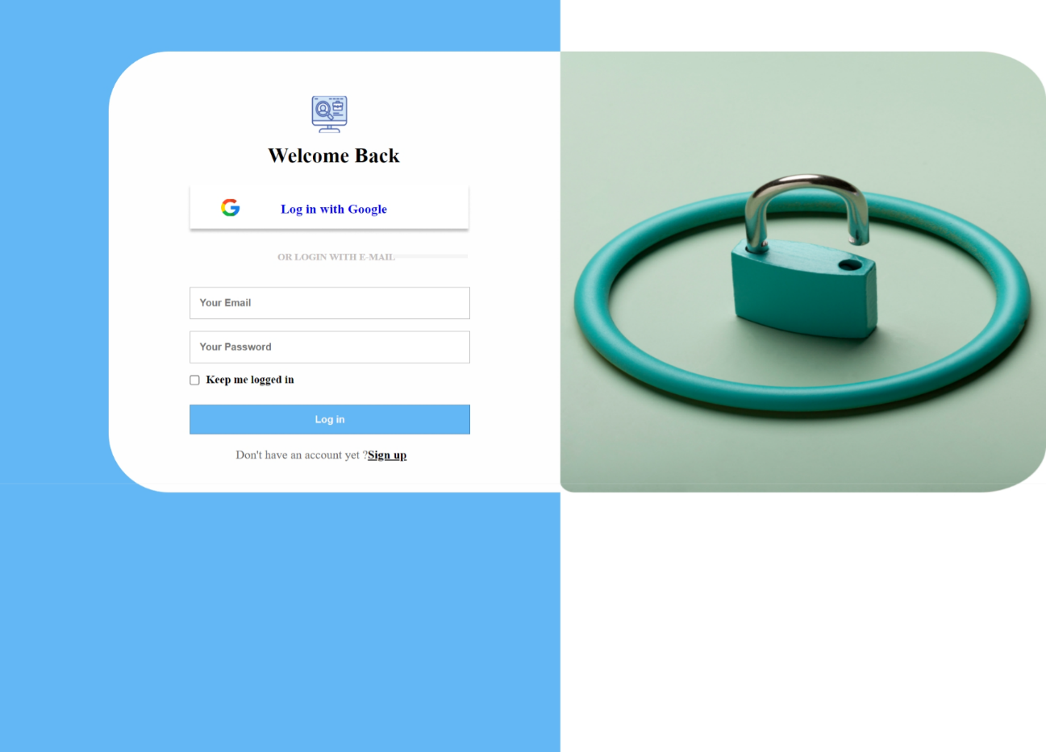

In this HTML program, we have created a login page for a website. The program starts with defining the document type as HTML5 and includes essential metadata in the `<head>` section. It references an external CSS file for styling. The main content is within the `<body>` element, enclosed in a container. The left container contains elements such as a logo, a 'Welcome Back' heading, a 'Log in with Google' button linked to Google's authentication service, and a login form with email and password input fields, a 'Keep me logged in' checkbox, and a 'Log in' button. Below the form, a message encourages users to sign up with a link. The right container includes an image, presumably for visual appeal. This program is an excellent example for students to learn about HTML structure, form elements, CSS styling, and the organization of a web page into different sections for specific content, along with the use of external CSS stylesheets and inline CSS for element-specific styling.

**Workshop 3**

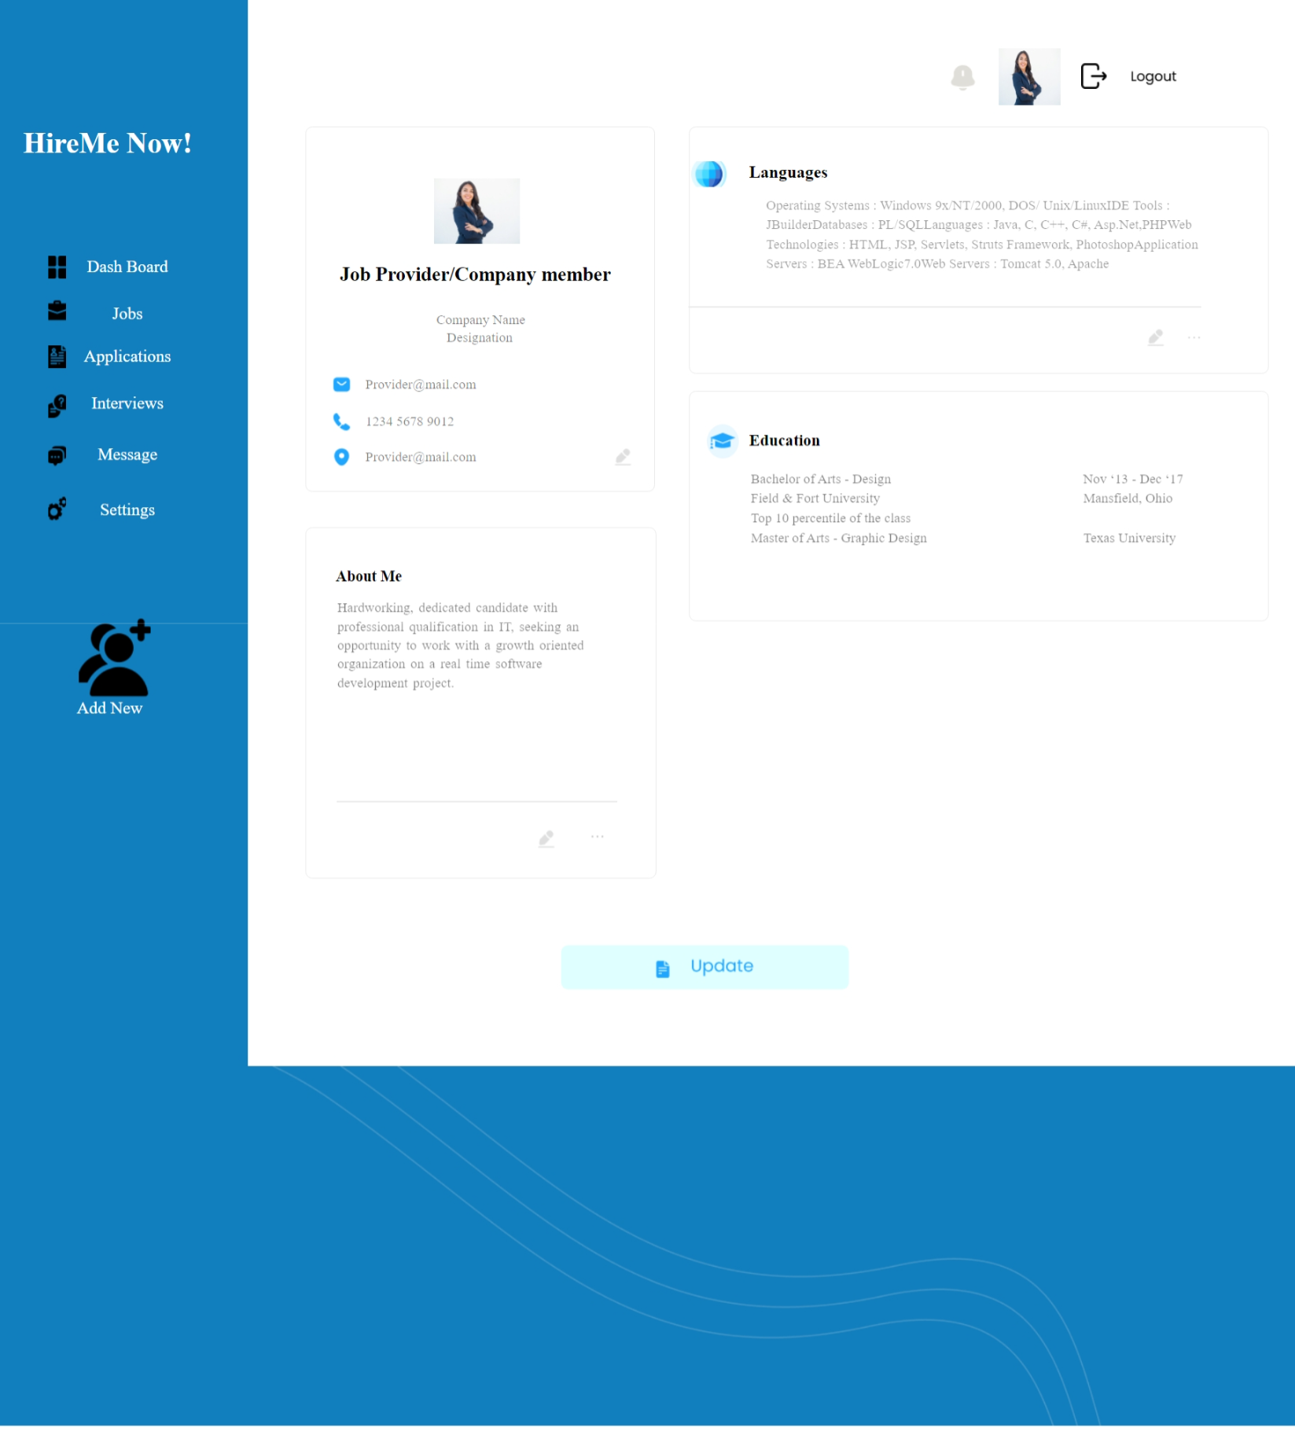

**Expected Output**

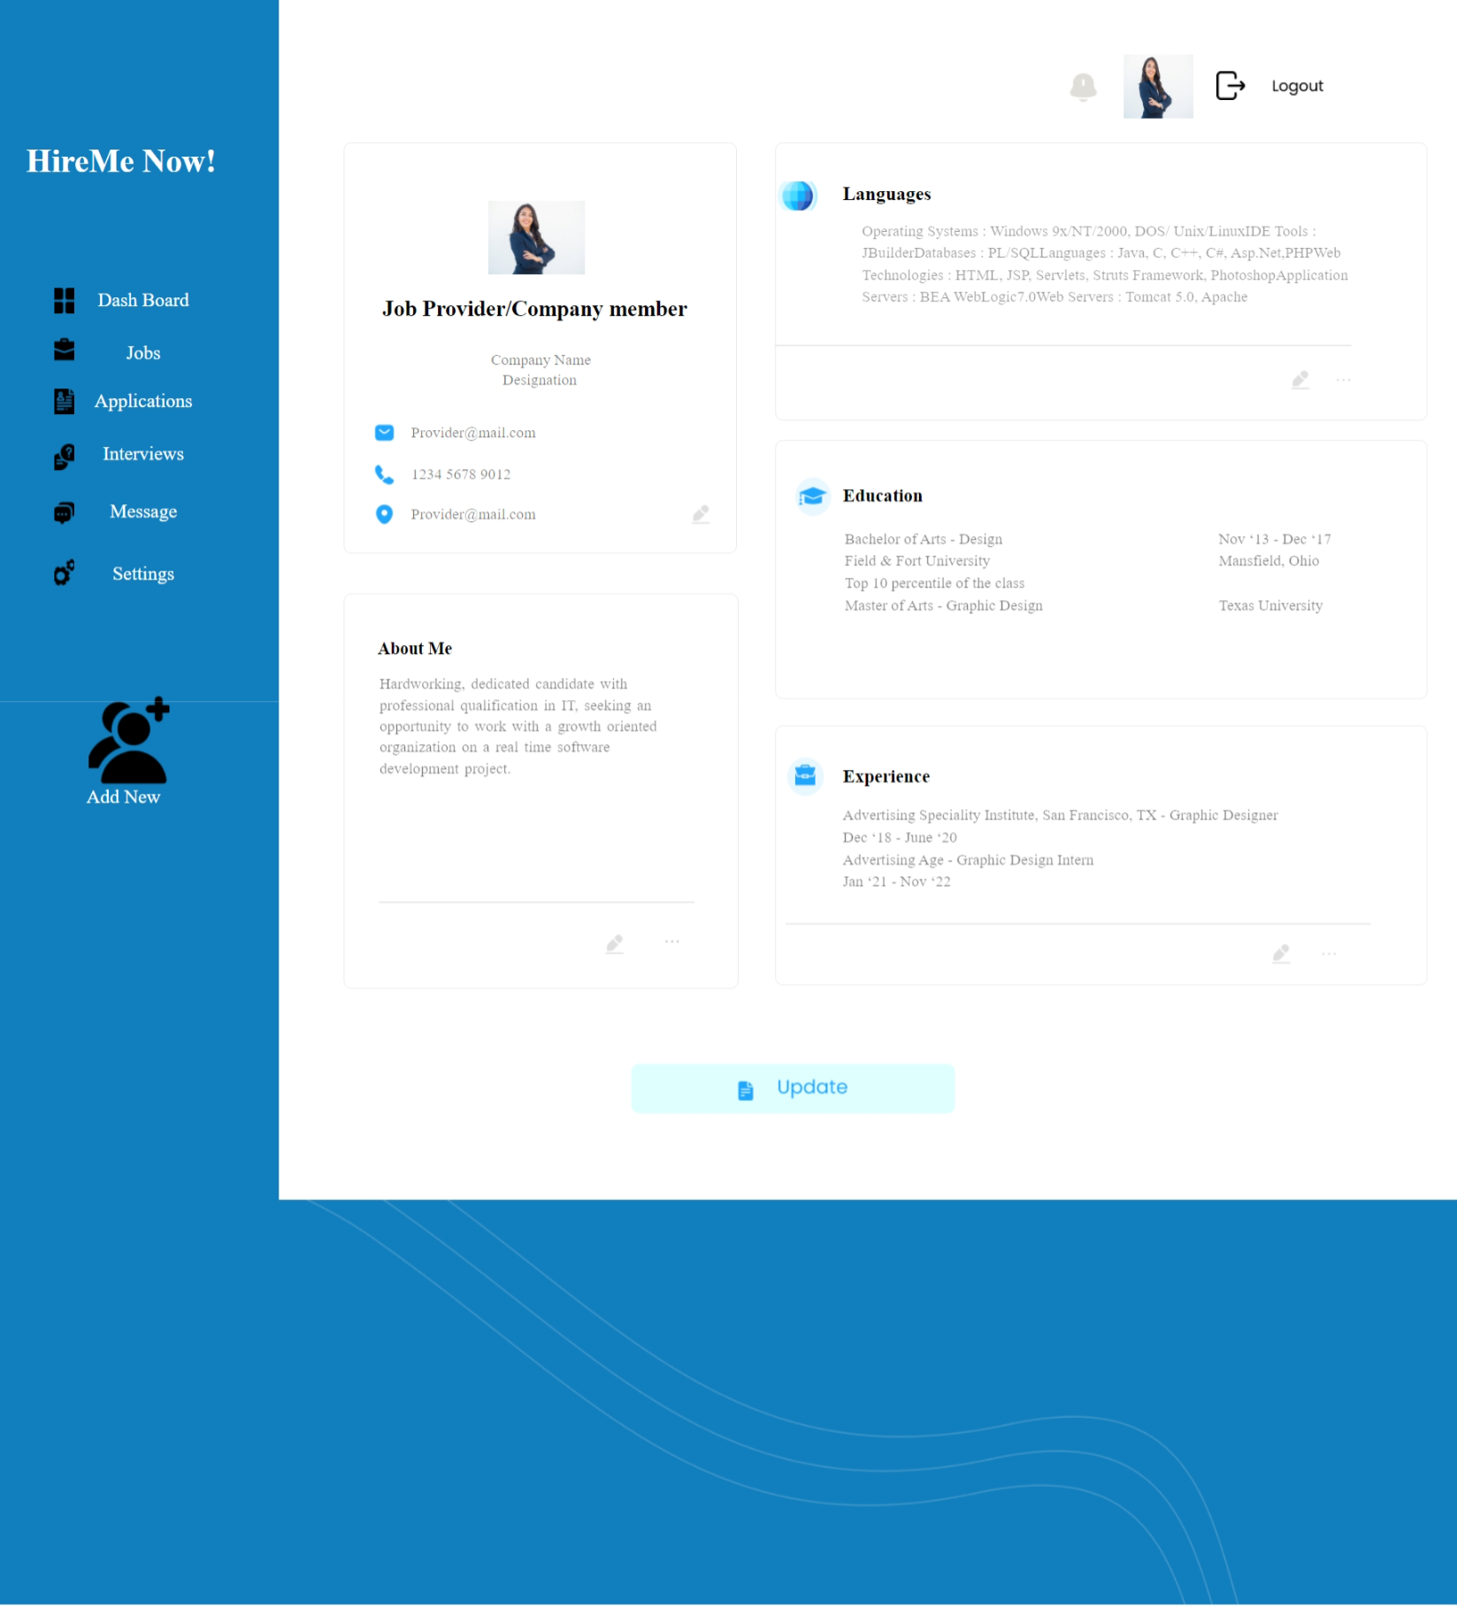

* 'hireMeNow' Section: This section serves as the page's header. It features a prominent 'HireMe Now!' heading, accompanied by a table that appears to represent a navigation menu. Each menu item, such as 'Dashboard,' 'Jobs,' 'Applications,' 'Interviews,' 'Messages,' and 'Settings,' is thoughtfully presented with icons and descriptive text, creating a visually engaging menu.
* 'box1' Section: Within this section, a confident businesswoman's image is displayed along with a heading that identifies the individual as a 'Job Provider/Company member.' The layout also includes spans for 'Company Name' and 'Designation,' followed by an unordered list detailing contact information. Icons and text are thoughtfully used for each contact detail.
* 'box2' Section: This section revolves around the topic 'About Me.' It commences with a heading and a descriptive paragraph outlining the person's professional qualifications and career aspirations. To separate content, a horizontal line is used, and icons for editing and options represented as three dots are included for enhanced user interaction.
* 'box3' Section: The 'box3' section focuses on 'Languages.' It begins with an image of a language icon, followed by a heading. A paragraph lists various skills and technologies. To maintain a consistent style, a line, an edit icon, and three dots are provided for further actions.
* 'box4' Section: In this section, the emphasis is on 'Education.' The layout consists of a circular image, an education icon, and a heading. It employs a two-column structure to present details about academic qualifications, institutions, and timeframes, providing a clear summary of the individual's educational background.
* 'box5' Section: 'Experience' takes the center stage in this section. It presents a list of job positions and their corresponding companies, accompanied by relevant dates. As seen in the preceding sections, there's a separating line, an edit icon for potential edits, and three dots that likely lead to additional options or actions.

**Workshop 4**

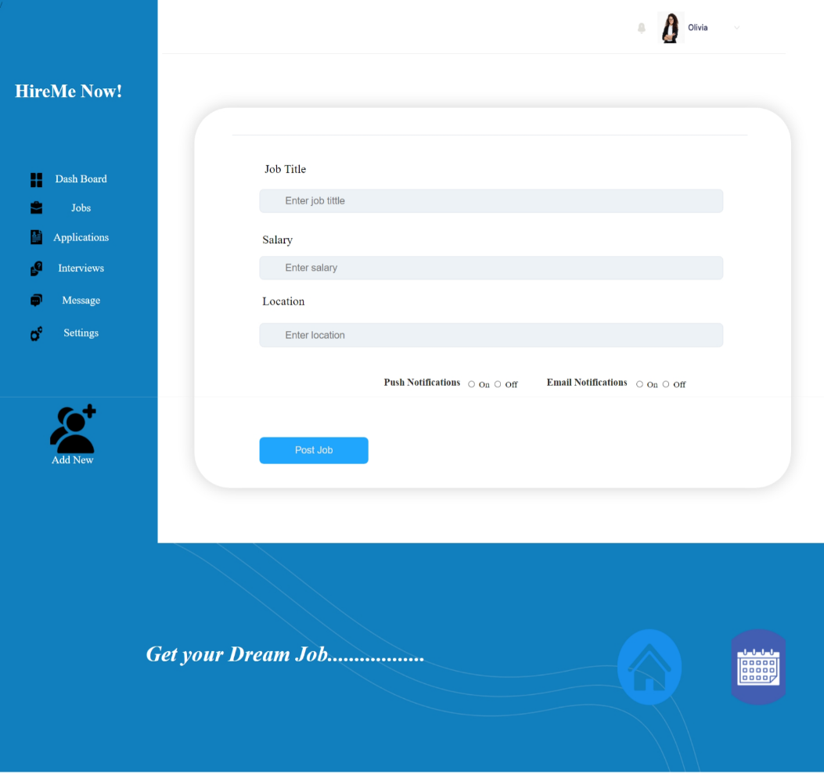

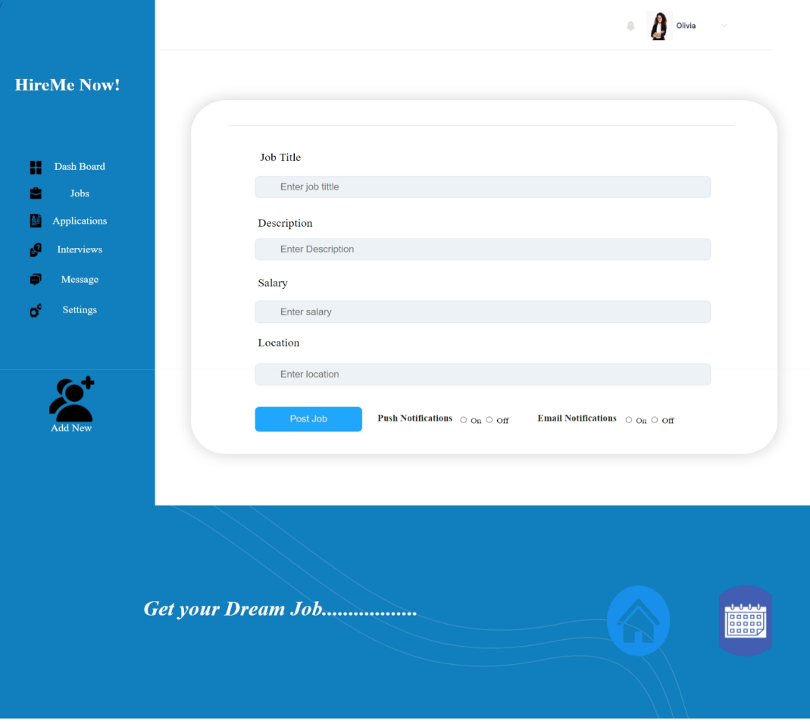**Expected Output**

* 'hireMeNow' Section: The page starts with a bold heading, 'HireMe Now!', which could serve as a slogan or the site's title. Below this, a table is used to create a menu, offering options like 'Dashboard,' 'Jobs,' 'Applications,' 'Interviews,' 'Message,' and 'Settings.' Each option is represented by an icon and a descriptive label.
* 'header' Section: In this section, an image and a horizontal line are placed. These elements may contribute to the header's visual design, possibly representing a logo or branding.
* 'box' Section: Within this segment, a form for job posting is presented. The form includes text input fields for job details, such as 'Job Title,' 'Salary,' and 'Location.' Labels are provided to clarify the purpose of each field. A 'Post Job' button allows users to submit job postings. Additionally, there's a section for notifications, where users can enable or disable 'Push Notifications' and 'Email Notifications.'
* 'footer' Section: The footer encompasses a full-width image, possibly for decorative or branding purposes. Below this image, a heading ('Get your Dream Job..................') is featured, which may serve as a slogan or an invitation for users to explore job opportunities. Lastly, two icons ('Home' and 'Calendar') are included, which could be part of the site's navigation or represent particular features.

**Workshop 5**

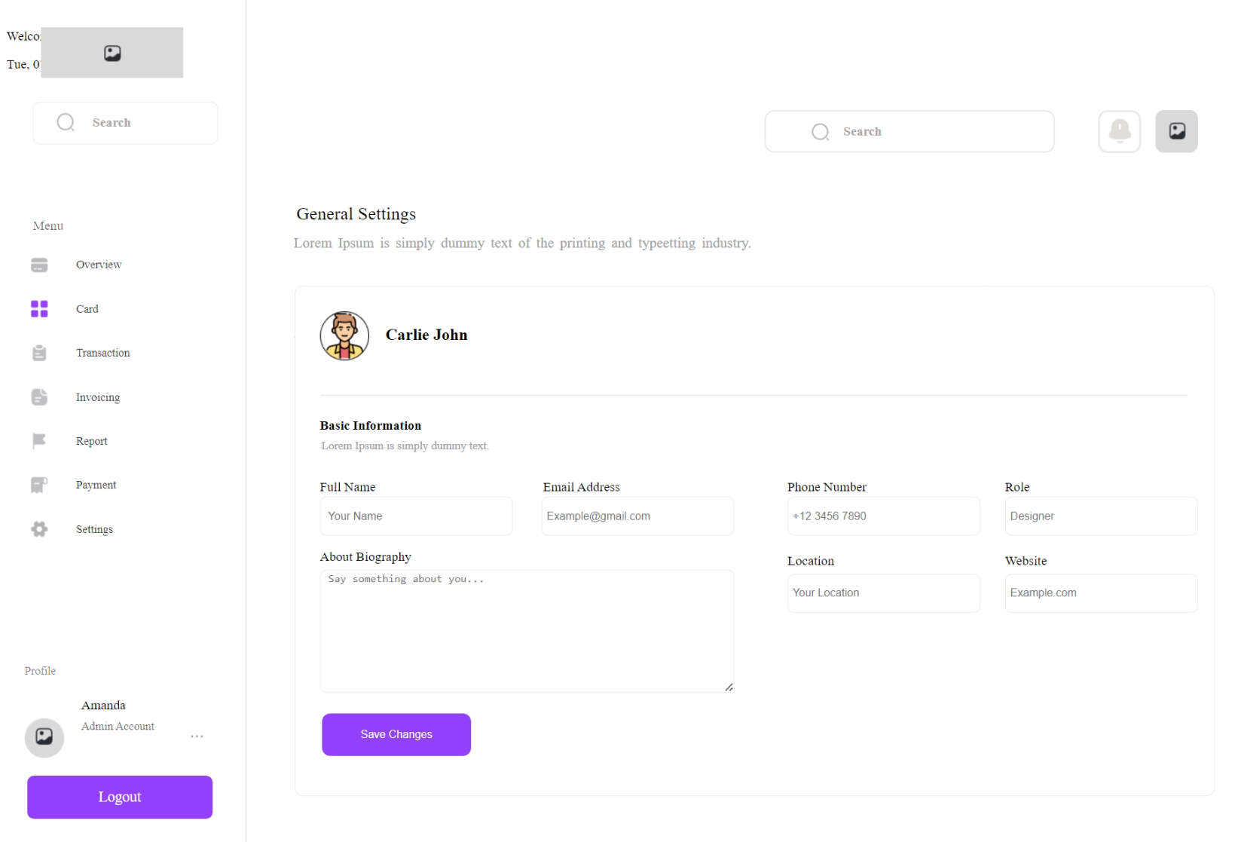

**Expected Output**

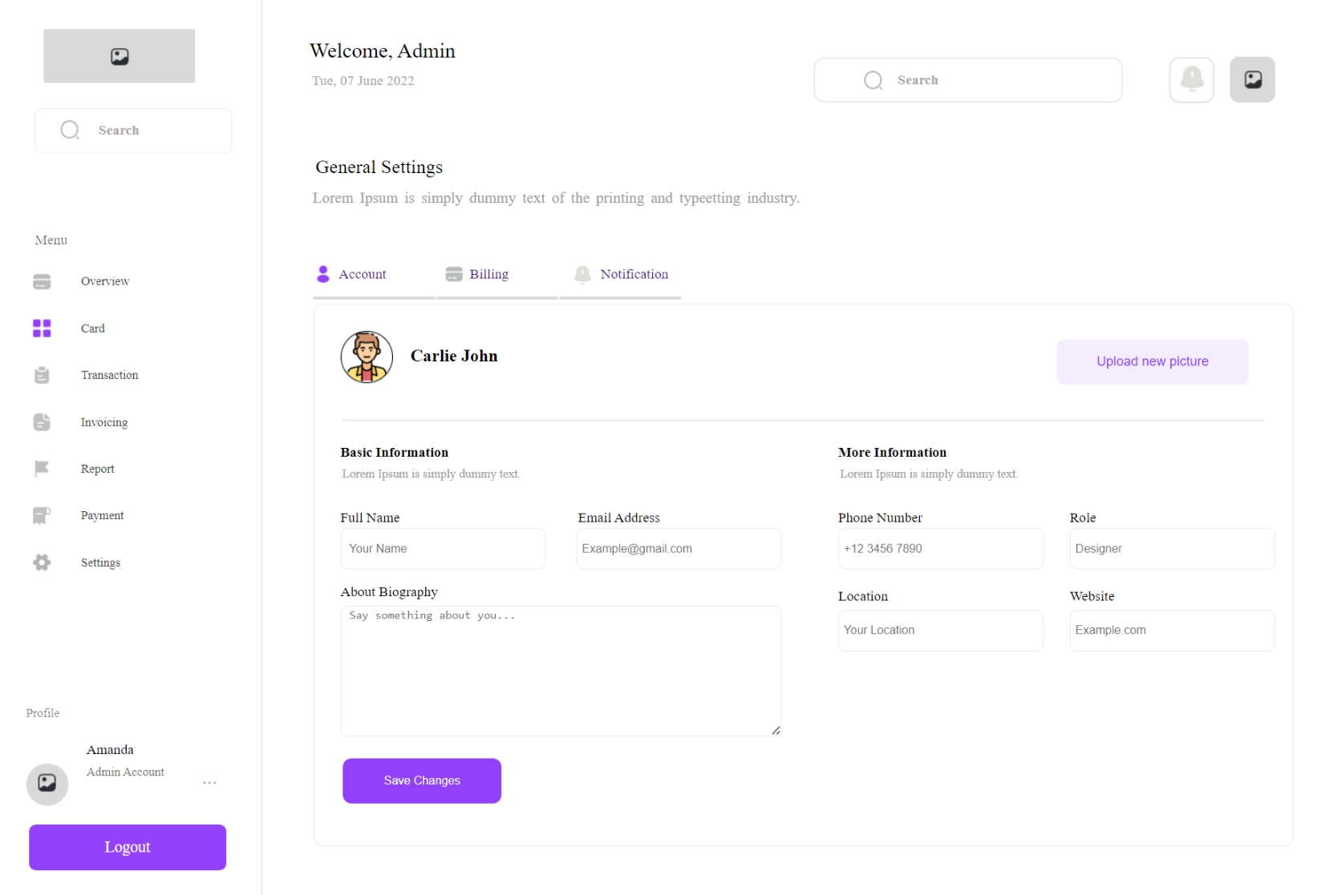

The provided HTML code defines a web page structured into sections and components. The 'container' div encapsulates the entire content, with 'box1' housing an image, possibly a logo. An input field for search, complemented by an icon and label, is present. The 'menu' section lists various items, each with an icon and label for potential navigation options. A 'logout' div displays user information, including name and role, and offers a 'Logout' button. A 'welcome' div greets the user and displays the date. Additional input fields for search and icons representing notifications and gallery are provided. The 'subHead' div introduces 'General Settings' with a description, while the 'nav' div offers navigation choices with icons and labels. Finally, the 'Bio' div focuses on user profiles, offering fields for personal information and a 'Save Changes' button to update the profile. This code can serve as a foundation for creating user profile pages with the included design elements and interactions, with styling further customizable via the external 'main.css' stylesheet.

**Conclusion**

In conclusion, CSS is your ticket to crafting visually captivating web pages. With the power to control fonts, colours, layouts, and more, you can transform ordinary content into a visually appealing masterpiece. As you continue your journey in web design, remember to practice and experiment, letting your .56 shine through. Whether it's styling lists, hyperlinks, tables, images, or adding decorative borders, CSS empowers you to make your web presence truly captivating. Embrace the art of web styling, and create web experiences that leave a lasting impression on your audience.